Ledger Lens AI – Receipt & Invoice Digitizer

Table of Content:
- Introduction | 2
- Problem Statement | 3
- Objectives | 4-5
- System Architecture | 6-7
- Technologies Used | 8-9
- Functional Modules | 10-11
- Data Validation Strategy | 12-13
- User Interface Design | 14-16
- Application of Regex and NLP  for Key Field Parsing | 17
- Conclusion | 18

1.Introduction

In today’s digital era, managing financial records such as receipts and invoices is still largely manual for individuals and small businesses. Physical bills are prone to loss, damage, and human error during manual entry. This creates challenges in expense tracking, auditing, budgeting, and financial analysis.
Ledger Lens AI is an intelligent Receipt & Invoice Digitizer designed to automate the process of extracting, storing, validating, and analysing bill data using Artificial Intelligence. The system leverages modern AI models, image preprocessing techniques, and a structured database to convert unstructured receipt images into meaningful, validated financial data.
The primary goal of this project is to reduce manual effort, improve accuracy, and provide clear insights into spending patterns through an easy-to-use web interface.

2.Problem Statement
Manual handling of receipts and invoices suffers from several limitations:
- Physical receipts are easily misplaced or damaged.
- Manual data entry is time-consuming and error-prone.
- GST and tax calculations are often misunderstood or ignored.
- Validating whether item totals match the final bill amount is difficult.
- Lack of centralized storage makes expense analysis challenging.
2.1 Problem Definition
Therefore, the core problem addressed by this project is:
How to design an intelligent system that can automatically digitize receipts and invoices, extract structured financial data, validate monetary values including taxes and discounts, store the data securely, and provide meaningful expense analytics through a user-friendly interface.
Ledger Lens AI addresses these issues by providing an automated, AI-powered system that digitizes receipts, extracts structured data, validates monetary values, and presents analytics in a user-friendly dashboard.

3.Objectives of the Project

The upgraded objective of the Ledger Lens AI project is to enhance the existing receipt and invoice management system by incorporating advanced Artificial Intelligence, Regex, and NLP-based techniques to further automate, validate, and analyse financial documents with greater accuracy and reliability. These enhancements focus on reducing manual intervention, improving data consistency, and strengthening financial validation mechanisms.
One of the major upgradations involves improving the digitization and parsing process of physical receipts and invoices. The system now supports more robust extraction of financial data from images and PDF files by applying AI-powered image analysis combined with Regex-based pattern matching and NLP-driven contextual understanding. This ensures accurate identification of key fields such as merchant name, date of purchase, itemized details, tax components, discounts, and total amount, even when receipt formats vary.
Another significant enhancement is the introduction of an improved bill validation mechanism, where extracted values are cross-verified through item-wise subtotal calculations and detailed tax analysis, including GST components. The recalculated total is compared against the billed amount within a defined tolerance range, allowing the system to automatically flag bills as PASSED or FAILED, thereby improving transparency and error detection.
The upgraded system also strengthens data persistence and management by securely storing all extracted and validated receipt data in a structured database. This enables long-term expense tracking, improved retrieval, and more reliable historical analysis. Furthermore, automatic expense categorization and enhanced analytical visualizations have been integrated to provide users with clearer insights into spending patterns and support informed financial decision-making.
Overall, the upgradations in Ledger Lens AI aim to transform the system into a more accurate, scalable, and user-friendly financial management solution, demonstrating the effective application of AI, Regex, and NLP techniques in real-world expense automation.

4.System Architecture
Ledger Lens AI follows a modular and layered architecture:
1. Frontend Layer
The frontend layer is developed using Streamlit, providing an interactive, web-based user interface for user interaction. This layer allows users to upload receipt images or PDF documents, view previously stored bills, perform bill-wise validation, and analyze expenses through interactive dashboards. The tab-based interface clearly separates functionalities such as receipt upload, bill history, analytics, and index performance, ensuring ease of navigation and an improved user experience.
2. AI Processing Layer
The AI processing layer is responsible for extracting meaningful and structured information from uploaded receipts. It leverages an AI model to analyze preprocessed images and generate structured output in JSON format, including merchant name, date, itemized purchases, tax details (GST, CGST, SGST, IGST), discounts, and total amount. This structured extraction enables seamless downstream processing and reliable data handling.
3. Regex & NLP Parsing Layer (Upgraded)
An additional parsing layer using Regular Expressions (Regex) and Natural Language Processing (NLP) has been integrated to enhance extraction accuracy. Regex is used to validate and normalize critical numerical and date fields, while NLP techniques help interpret contextual information such as merchant identification, line-item association, and differentiation between subtotal, taxes, and final total. This hybrid parsing approach improves robustness across varying receipt formats and noisy OCR outputs.

4. Preprocessing Layer
The preprocessing layer enhances receipt image quality before AI analysis. Techniques such as grayscale conversion and automatic contrast adjustment are applied to improve text clarity and reduce noise. This step significantly increases the effectiveness and accuracy of AI-based extraction, especially for low-quality or scanned receipts.
5. Database Layer
The database layer uses SQLite for persistent storage of extracted and validated receipt data. Each record stores structured financial fields, raw extracted JSON, categorized expense details, and a unique file hash to prevent duplicate uploads. This ensures data integrity, efficient retrieval, and long-term expense tracking.
6. Validation & Analytics Layer
The validation and analytics layer performs automated bill-wise verification by recalculating totals using item-level subtotals, tax components, and discounts. The recalculated amount is compared with the extracted bill total within a tolerance range, and bills are marked as PASSED or FAILED. Additionally, this layer generates analytical insights through category-wise summaries, bar charts, and pie charts, supporting informed financial analysis and decision-making.

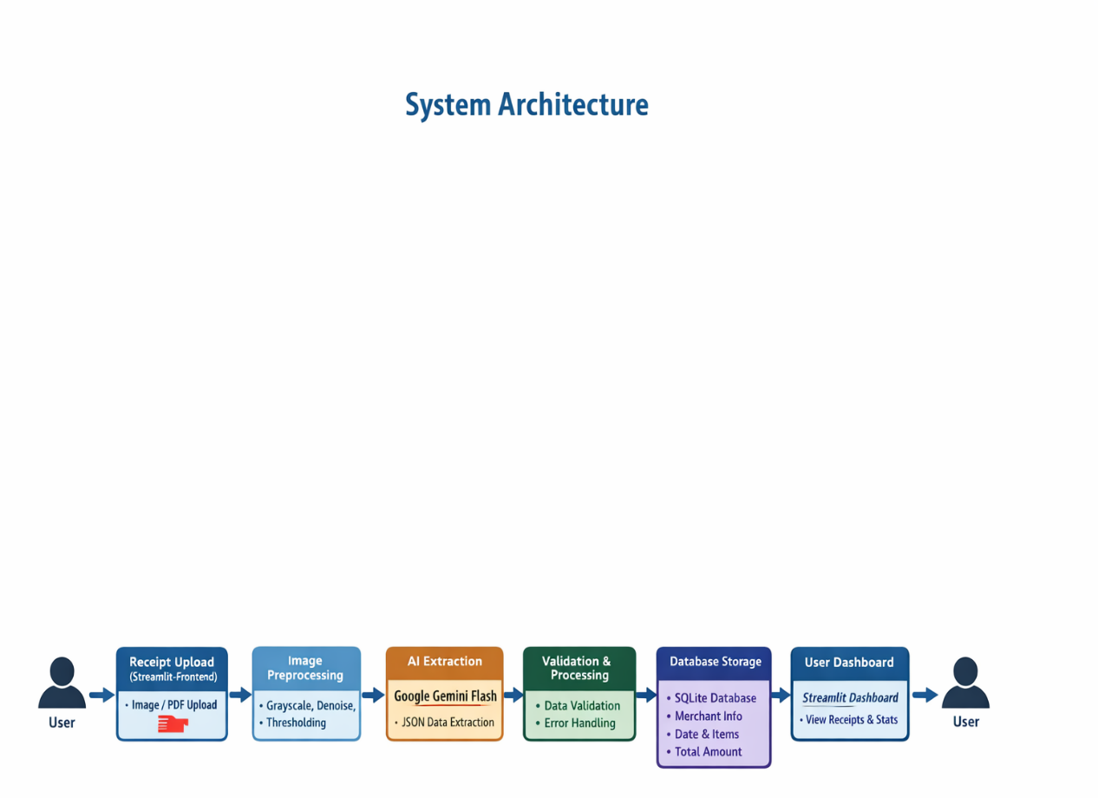
5.Technologies used
The LedgerLens AI project is developed using a combination of modern programming tools, web technologies, and Artificial Intelligence frameworks to ensure efficient receipt processing, validation, and analytics.
Python is used as the core programming language due to its simplicity, flexibility, and strong support for data processing and AI integration. It enables seamless interaction between image processing, AI models, database operations, and analytics.
Streamlit is used to build the web-based user interface. It allows rapid development of interactive dashboards with minimal code and provides features such as file upload, tab-based navigation, tables, metrics, and visualizations, making the application user-friendly.
Google Gemini Generative AI API is used for intelligent receipt analysis. The AI model processes receipt images and extracts structured information such as merchant details, line items, taxes, discounts, and total amount in JSON format.
SQLite is used as the backend database to store extracted receipt data persistently. It is lightweight, easy to integrate, and suitable for small to medium-scale applications.
Pandas is used for data manipulation and analysis, including grouping, filtering, and summarizing expense data.
Pillow (PIL) is used for image preprocessing tasks such as grayscale conversion and contrast enhancement, improving AI extraction accuracy.
Matplotlib is used to generate visual analytics such as bar charts and pie charts, enabling clear visualization of spending patterns.
PDF2Image is used to convert PDF receipts into images for AI processing.
Together, these technologies create a robust, efficient, and scalable system for automated receipt management.
Regular Expressions (Regex) and Natural Language Processing (NLP) techniques are applied to validate, normalize, and contextually interpret extracted fields such as dates, tax values, totals, and merchant names.

6.Functional Modules
The LedgerLens AI system is divided into several functional modules, each responsible for a specific task in the receipt digitization and analysis process. This modular approach improves clarity, maintainability, and system efficiency.
1. Receipt Upload Module
This module allows users to upload receipt and invoice files in JPG, PNG, or PDF formats. The system checks for duplicate uploads using file hashing to avoid storing the same receipt multiple times. Uploaded PDF files are automatically converted into images, ensuring consistent processing across file types.
2. Image Preprocessing Module
The image preprocessing module enhances the quality of uploaded receipts to improve data extraction accuracy. Techniques such as grayscale conversion and contrast enhancement are applied to reduce noise and make text more readable for the AI model.
3. AI Extraction Module
This module uses the Google Gemini Generative AI model to analyze receipt images and extract structured financial data. The extracted information includes merchant name, date, currency, item details, taxes (GST, CGST, SGST, IGST), discounts, and total amount. The output is returned in a strict JSON format to ensure consistency and reliability.

4. Database Storage Module
The database module stores all extracted receipt data in a SQLite database. Each record includes receipt metadata, categorized expense information, raw extracted JSON, and a unique file hash. This enables persistent storage and easy retrieval of historical bills.
5. Bill Register and History Module
This module provides a tabular view of all stored receipts. Users can select individual bills using a Bill ID to view detailed information, including line items and merchant details. It serves as a digital filing cabinet for receipts.
6. Amount Validation Module
The amount validation module verifies the correctness of each bill by calculating the item subtotal, adding extracted or inferred taxes, subtracting discounts, and comparing the calculated amount with the actual billed total. A tolerance mechanism is applied to handle rounding differences.
7. Analytics Module
The analytics module generates insights into spending behavior by providing category-wise summaries, bar charts, and pie chart visualizations. It helps users analyze expenses and make informed financial decisions.

7.Data Validation Strategy
Data validation is a critical component of the LedgerLens AI system to ensure the accuracy and reliability of extracted financial information. Since real-world receipts often contain incomplete, unclear, or inconsistent data, the system follows a practical and industry-inspired validation strategy.
The first step in validation is item-level verification. The system calculates the item subtotal by summing the prices of all extracted line items. This ensures that individual item values are correctly interpreted before further calculations are performed.
The second step involves tax validation. If tax details such as GST, CGST, SGST, IGST, or other applicable taxes are explicitly mentioned on the receipt and extracted by the AI, these values are directly added to the item subtotal. However, many receipts do not clearly itemize tax amounts. In such cases, the system applies implicit tax inference, where the tax amount is calculated as the difference between the billed total and the item subtotal. This approach reflects real-world accounting practices.
Next, discount handling is performed. Any discounts identified on the receipt are subtracted from the calculated amount to ensure accurate final computation.
The system then calculates the expected total amount using the formula:
Item Subtotal + Total Tax − Discount.

To handle rounding errors and minor discrepancies common in billing systems, a tolerance threshold is applied. The calculated total is compared with the actual bill total, and the bill is marked as valid if the difference falls within the acceptable tolerance range.
This multi-level validation strategy ensures accurate bill verification while maintaining flexibility to handle real-world receipt variations, making LedgerLens AI both reliable and practical.

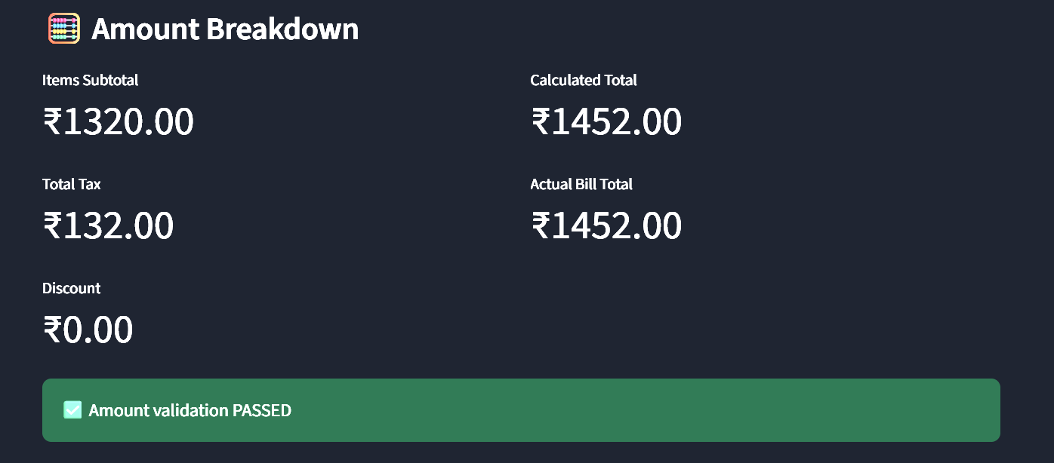
8.User Interface Design
The user interface of LedgerLens AI is designed with a focus on simplicity, clarity, and ease of use, ensuring that both technical and non-technical users can interact with the system effectively. The interface is developed using Streamlit, which enables a clean, responsive, and interactive web-based dashboard.
The application follows a tab-based layout, dividing the system into three main sections: Upload, History, and Analytics. This design ensures logical separation of functionalities and allows users to navigate the system effortlessly without confusion.
In the Upload tab, users can upload receipt or invoice files in image or PDF format. The interface displays the original receipt alongside the preprocessed version, helping users visually understand how image enhancement improves extraction accuracy. Clear buttons, progress indicators, and success or error messages guide the user throughout the extraction process.
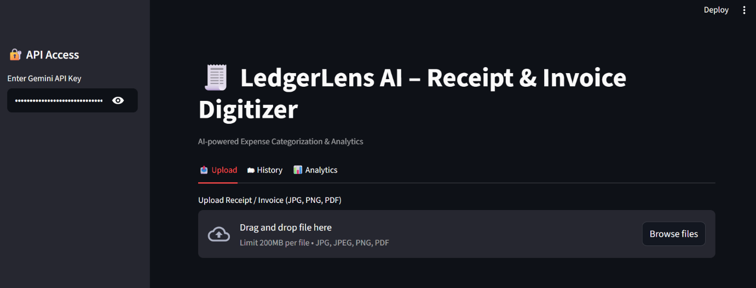
The History tab acts as a digital bill register, displaying all stored receipts in a structured table format. Users can select individual bills using a Bill ID to view detailed information such as merchant name, line items, and amount breakdown. The bill-wise validation results are presented using clear metrics and visual indicators, making discrepancies easy to identify.
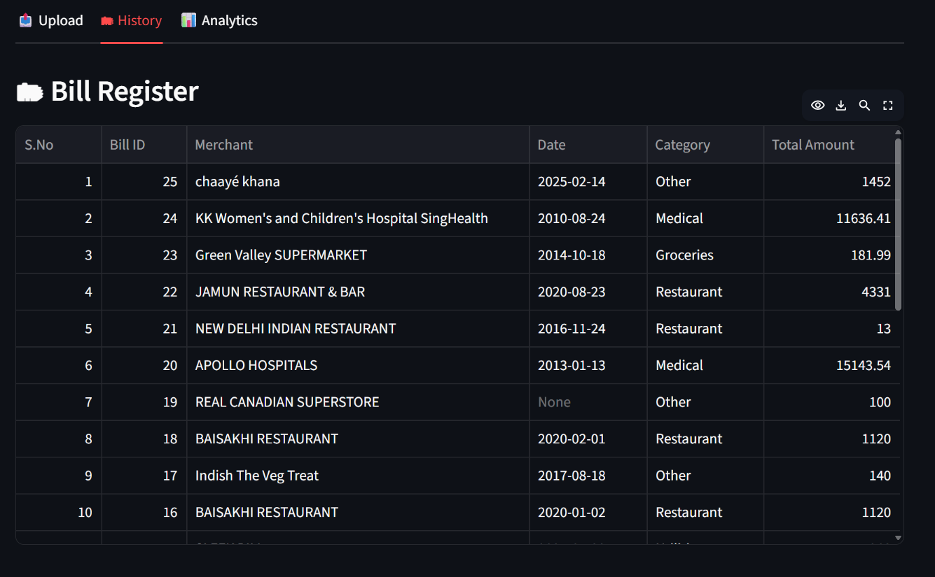
The Analytics tab presents expense insights through intuitive charts and summaries. Bar charts and pie charts are used to visualize category-wise spending, helping users quickly understand their expenditure patterns.
Overall, the user interface emphasizes usability, transparency, and feedback, ensuring a smooth user experience while effectively presenting complex financial data in a simple and understandable manner.
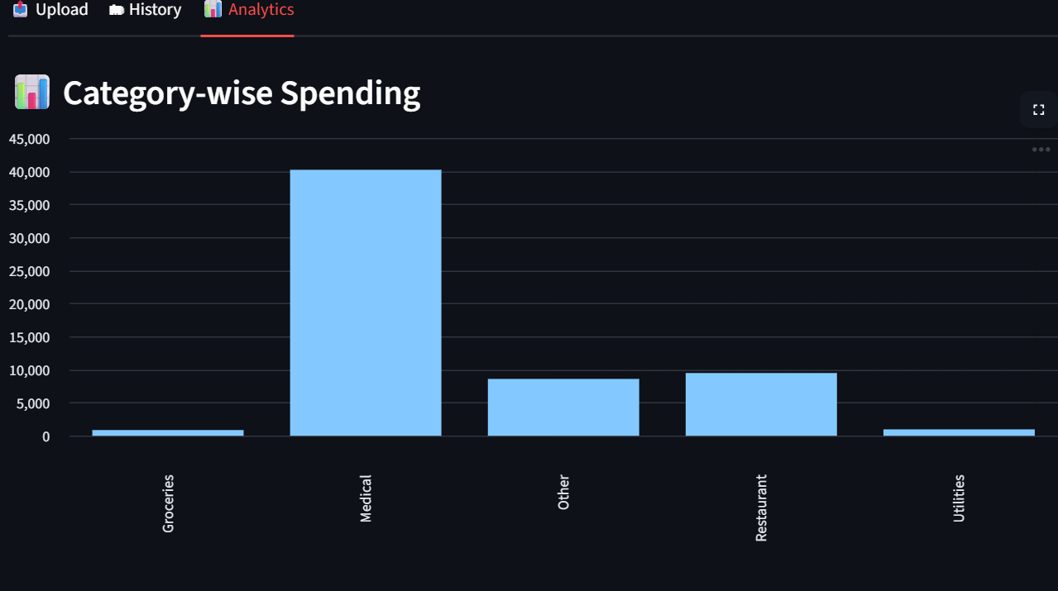
The Indexed Performance is another tab which is used to check the date, merchant, Invoice of the uploaded bill. It validates an provide a clear representation of the result of validation.
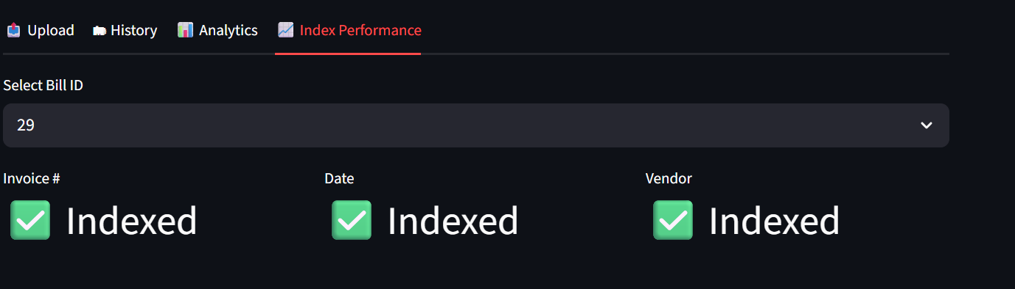

9.Application of Regex and NLP for Key Field Parsing
To improve the accuracy and reliability of information extraction from receipts and invoices, an advanced Regex-based and NLP-assisted parsing mechanism was introduced in the system. This upgrade addresses common challenges such as inconsistent receipt formats, noisy OCR output, and variations in how key fields are represented across vendors.
After the AI model extracts raw textual content in JSON format, Regular Expressions (Regex) are applied to identify and validate critical fields such as invoice date, total amount, tax components (GST, CGST, SGST, IGST), currency symbols, and invoice numbers. Regex patterns are designed to handle multiple formatting styles (e.g., different date formats, tax labels, and numeric separators), ensuring consistent data extraction even when receipt layouts vary.
In parallel, Natural Language Processing (NLP) techniques are used to interpret unstructured text and contextual keywords. NLP helps in:
- Identifying the merchant name based on semantic cues
- Distinguishing between subtotal, tax amounts, and final total
- Extracting line items and associating prices with corresponding product names
- Resolving ambiguities where multiple numeric values appear on a single receipt
The combined use of Regex and NLP enables post-processing validation, where extracted values are cross-checked for correctness and completeness. This hybrid approach significantly reduces extraction errors caused by OCR noise and improves overall system accuracy.

10.Conclusion
The LedgerLens AI project successfully demonstrates the practical application of Artificial Intelligence in automating receipt and invoice management. The system effectively transforms unstructured receipt images and PDF documents into structured digital data by integrating image preprocessing, AI-based information extraction, and intelligent data handling techniques. This approach significantly reduces manual effort while improving the accuracy and efficiency of expense tracking.
One of the major strengths of the project lies in its robust data validation strategy, which verifies the correctness of bills by analyzing item-wise subtotals, applicable taxes, discounts, and final billed amounts. By incorporating both explicit tax extraction and implicit tax inference mechanisms, the system is capable of handling real-world variations in billing formats and ensures reliable validation outcomes.
The project also offers a user-friendly and interactive interface that allows users to upload receipts, maintain historical records, perform bill-wise validation, and analyze expenses using visual reports. The use of a persistent database ensures secure storage and efficient retrieval of financial data, while analytical insights such as category-wise summaries support improved budgeting and informed financial decision-making.
Overall, LedgerLens AI addresses a real-world financial management problem and highlights how AI can be effectively integrated into expense management systems to enhance efficiency, transparency, and reliability. The project provides a strong foundation for future enhancements such as cloud deployment, multilingual receipt support, automated report generation, and data export features, making it scalable for real-world applications.

